South Bay

A non-native beetle known to attack dozens of California tree species has made its way to the Bay Area. Here's what to know.



[Lucas Combos,](https://patch.com/users/lucas-combos)Patch Staff

Posted Fri, Aug 23, 2024 at 12:52 pm PT|Updated Fri, Aug 30, 2024 at 9:56 am PT

A magnified photo shows an adult female invasive shothole borer. Female beetles are 
about the size of a sesame seed.

A magnified photo shows an adult female invasive shothole borer. Female beetles are about the size of a sesame seed. (Courtesy of John Kabashima/UC Cooperative Extension)

SAN JOSE, CA — Invasive beetles the size of a sesame seed could pose a threat to trees across the region after their presence was confirmed in San Jose, officials announced Friday.

According to the Santa Clara County Division of Agriculture, the invasive shothole borer is a non-native bottle known to attack more than 65 tree species in California. Researchers have found the pests can kill at least 17 species of trees, including box elder, California sycamore and Japanese maple trees.

The shothole borer established populations in Southern California in the early 2000s where officials said the pests were responsible for killing tens of thousands of trees. While their flight abilities are limited, they can hitch rides on infested waste, firewood, or packing materials.

The county is unsure how — or when — the tiny insects arrived in the South Bay or how widespread the infestation may be, and agricultural researchers are working on surveillance methods to learn more. Officials said the beetles tunnel into host trees and introduce a fungus that can cause disease in trees, preventing them from properly utilizing water and nutrients or even killing them.

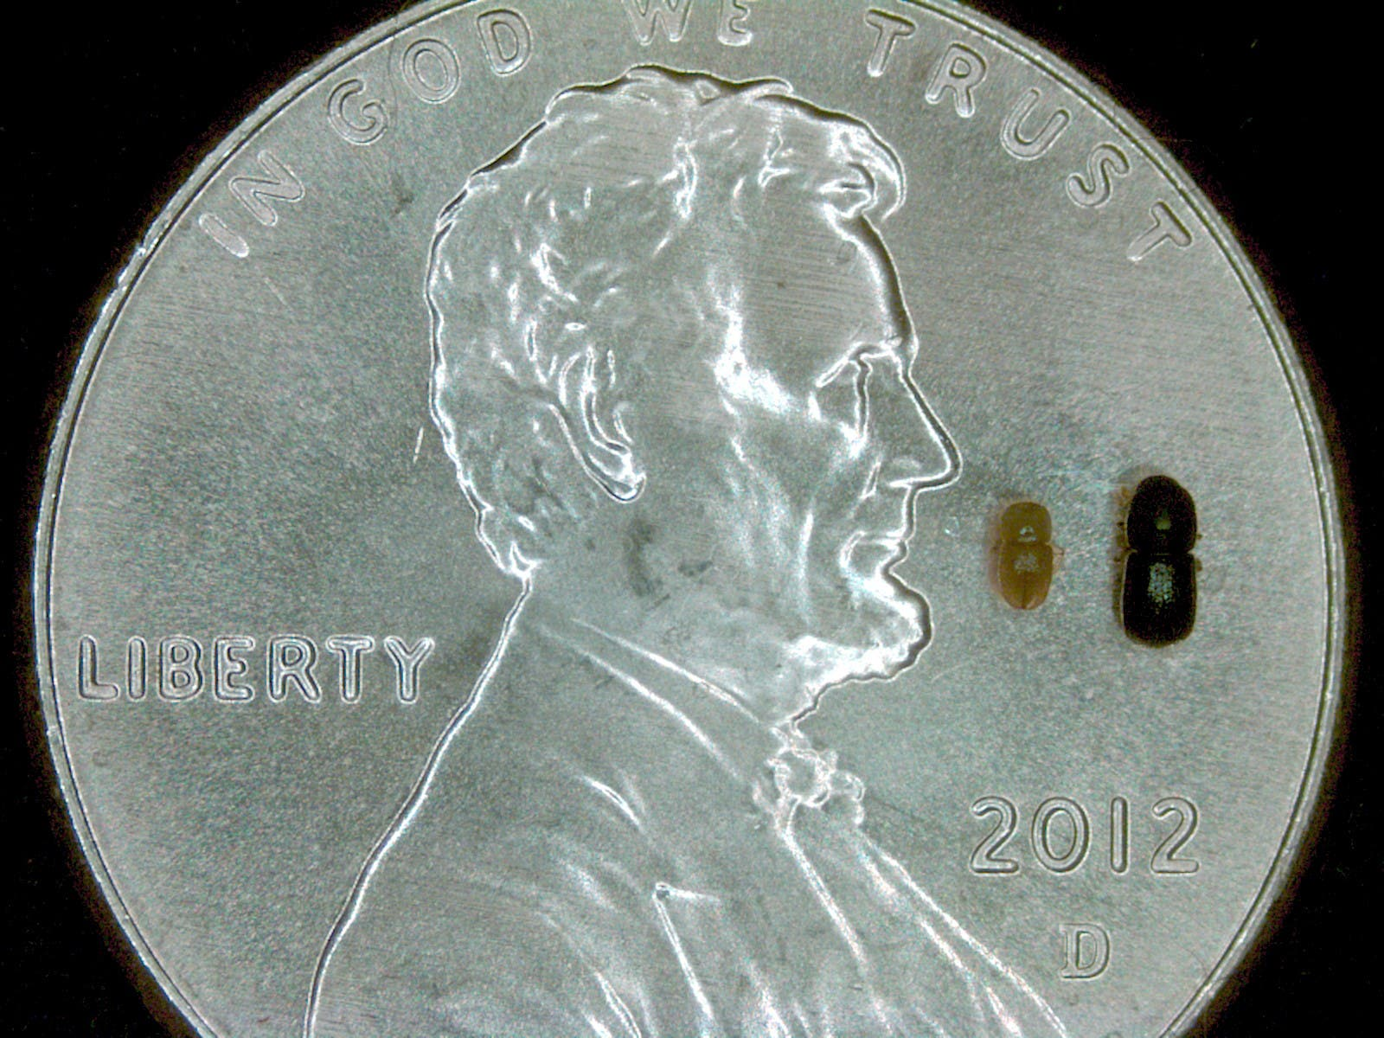

Photo of a male (left) and female (right) invasive shothole borer on a penny. (Courtesy of Akif Eskalen/UC Davis)

While it may not be possible to eradicate the insects now that they have arrived, the county says there are a few ways to reduce the threat, starting with identifying trees that may be infested.

Bottom of Form

"We're asking for the community's help in identifying trees that have been attacked by invasive shothole borers, which will help us determine the extent of the infestation," said Drew Raymond, the county's acting agricultural commissioner. "While we probably can't get rid of the invasive shothole borer at this point, we can contain the infestation to protect as many of our trees as possible."

According to Raymond's office, the warning signs that a tree may be infested include "perfectly round" entry or exit holes as small as the tip of a ballpoint pen. The area around the holes may show signs of wet staining, gumming, insect waste, boring dust, or "sugary buildup."

Anyone who suspects an infestation of trees on their property can contact the Division of Agriculture at 408-918-4610, where biologists can assist in further identification. Property owners who need to remove or dispose of infested trees should refrain from throwing them away without first contacting an arborist.

More information on the [invasive shothole borer](https://ipm.ucanr.edu/legacy_assets/pdf/pestnotes/pninvasiveshotholeborer.pdf) is available from the Statewide Integrated Pest Management Program.