Food Systems Program

# Creating Value-Added Products on Small Farms

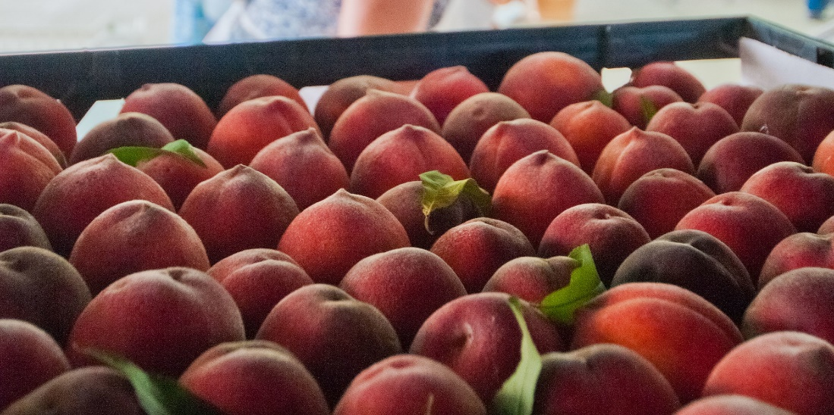

When

Tuesday, Oct. 8, 4-5:30 p.m.

**Zoom Link**

<https://ucanr.zoom.us/j/92333557128>

**Call In**

1-669-900-6833

Meeting ID: 923 3355 7128

## Agenda

**Participant Resources**

Website: [UC Food Safety: Starting a Food Business](https://ucfoodsafety.ucdavis.edu/processing-distribution/starting-food-business)

PDF:[**Value-Added On-Farm Processing - Regulatory Considerations**](https://ucfoodsafety.ucdavis.edu/sites/g/files/dgvnsk7366/files/inline-files/287951.pdf)

PDF:[**California Processed Food Registration timeline**](https://ucfoodsafety.ucdavis.edu/sites/g/files/dgvnsk7366/files/inline-files/287953.pdf)

**PDF:** [**California Cannery License timeline**](https://ucfoodsafety.ucdavis.edu/sites/g/files/dgvnsk7366/files/media/documents/Cannery%20brochure%20with%20UC%20Lab%20link%20%26%20AFDO%20edit%20287956.pdf)

Website: [California Cottage Food Operations](http://ucanr.edu/sites/cottagefoods/)

4:00 p.m. Introductions

4:15 p.m. Presentation by UCCE Advisor Olivia Henry

* Fundamentals of Value-Added Enterprises
* Licensing Pathways
* Marketing Pathways
* Profitability Calculator

4:30 p.m. Presentations by Producers

* + - Tree Kilpatrick, The Cloverleaf Farm
    - Pat Calvert, Ciarlo Fruit & Nut
    - Josh Rickett, Sun & Cellar

5:00 p.m. Panel Q&A

5:30 p.m. Evaluation & Close