Updates to Office 365/Outlook Name Display
In accordance with the Gender Recognition and Lived Name policy, UC Davis has recently implemented changes to Microsoft 365. In Microsoft Outlook, your display name will automatically reflect what is listed as Name in UCPath. If your Name had not been updated in UCPath, you may have already noticed changes to your display name such as the inclusion of your middle name. To correct or update, please go to UCPath to make changes for your Name. Instructions can be accessed at Update My Name.

After UCPath confirms updates, changes will appear in 24-72 hours (about 3 days) in UC Davis Microsoft 365. If it has been longer than 72 hours, please verify the updates are reflected in UCPath as appropriate. Log out and back into systems to also assist in updating the new data. If this persists, please contact UCD IT Express. Some platforms may not reflect lived names immediately after a change is made. For example, the Microsoft Teams client may cache some data, like display names, for up to 28 days.

Tips Updating Name in UCPath:
After making your changes in UCPath, make sure to click the Submit button to get to the Save confirmation screen. Once on the Save Confirmation screen, click the Ok button to receive an email confirmation confirming the changes.

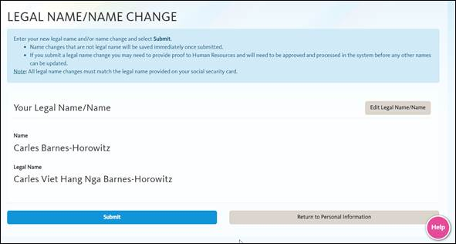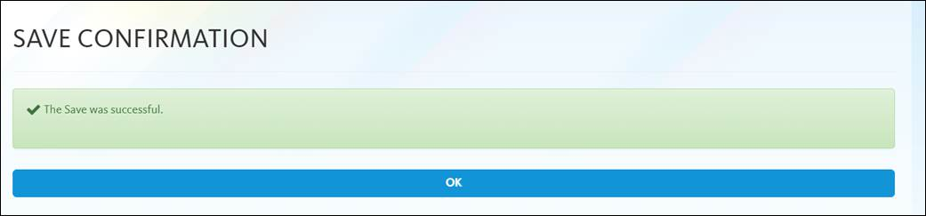

UCPath will then confirm the name change:
