

**Facebook Live**

**How to Create a County NEP Page and Closed Group**

## How to Create a Facebook Page

### Step 1: Go to "Create Page" Link

Go to <https://www.facebook.com/pages/create/>

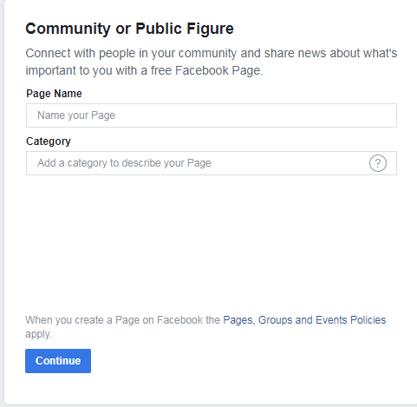

### Step 2 : Choose a Page Type

Click to choose: Company, Organization or Institution

### Step 3: Choose a Category

Click to choose: Education

### Step 4: Choose a Business Name

Enter: XXXX County Nutrition Education Program

*\*use the name of your county. For example, Fayette County Nutrition Education Program.*

Category: Education Website

Username:@XCNEP

*\*use the initials of your county plus NEP if possible. For example, Fayette County would be @FCNEP; Edmonson County would be @ECNEP*

### Step 5: Agree to Facebook Pages Terms

### Step 6: Click "Get Started"

### Step 7: Set Up Page

Add a Short Description:

The goal of NEP is to educate limited resource families with young children and SNAP clientele to plan nutritious meals on a limited budget. Administered by the University of Kentucky Cooperative Extension Service, an equal opportunity university.

Add Story:

The Kentucky Nutrition Education Program (KYNEP) encompass two separate USDA programs: The Expanded Food and Nutrition Education Program (EFNEP), and the Supplemental Nutrition Assistance Program (SNAP-Ed). Both programs are administered by the University of Kentucky Cooperative Extension Service, and target low income families and individuals with nutrition education. The goals of both are to educate limited resource families with young children and SNAP eligible individuals to plan nutritious meals on a limited budget, acquire safe food handling practices, improve food preparation skills and change behavior necessary to have a healthy lifestyle.

Administered by the University of Kentucky Cooperative Extension Service, an equal opportunity university.

Add Contact info:

Your phone number and email address.

### Step 8: Add Profile Picture

### Upload picture provided by NEP

### Step 9: Add a Cover picture

### Upload picture provided by NEP

### Step 10: Edit/Manage Settings

We recommend making your FCS Agent an Admin if you're not friends with the person you're adding, they'll have to [accept your invite](https://www.facebook.com/help/1021117938014211?helpref=faq_content) before they can start helping you manage your Page.) You should have at least 2 admins who can manage the page.

1. Click Settings at the top of your Page
2. Click Page Roles in the left column
3. Type a name or email in the box and select the person from the list that appears
4. Click Editor to select a role from the dropdown menu
5. Click Add to enter your password to confirm

**How to Create a Facebook Group**

**Step 1: Find "Add Group"**

From the Facebook County Nutrition Education Program “Home page” you just created, go to Explore - Groups section on the left side menu and click on, "Groups."

You'll be taken to a page that displays the option to create a group as well as showing you some:

* Pending Invites
* Favorites
* Your Groups
* Groups You Manage

Facebook also offers an alternate way to create a new group:

* From your profile page, Select “Create” and from the drop down list choose, "Group."

**Step 2: Click "Create Group"**

To begin the process of creating a group, click "Create Group" in the upper right hand corner.

Once you choose that option, a lightbox will open where you can begin to add your Facebook group details

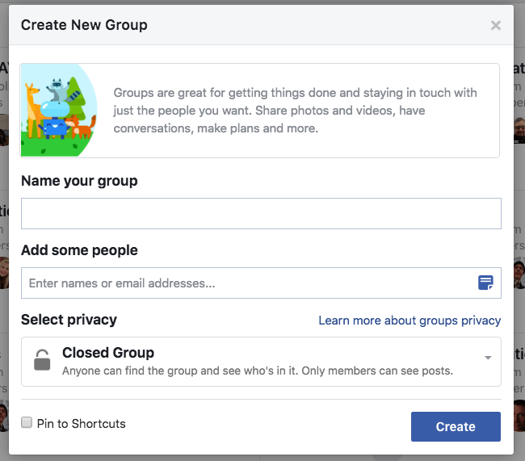:

**Step 3: Name Your Group**

The first thing you need to do is Name your group. This name will be searchable, so make it something people can easily find.

Enter: XXXX County Facebook Live Healthy Choices for Every Body

*\*use the name of your county. For example, Fayette County Facebook Live Healthy Choices for Every Body*

**Step 4: Add Members**

The second thing you need to do is Add a person. Facebook actually requires you add at least 1 friend to the group at this stage before you can proceed.

Add some people: We recommend adding your FCS agent during this step

**Step 5: Choose Privacy Setting**

Next, you will need to Select privacy setting. There can be confusion about [what privacy setting a group should have](https://www.facebook.com/help/286027304749263)-- Open, Closed or Secret:

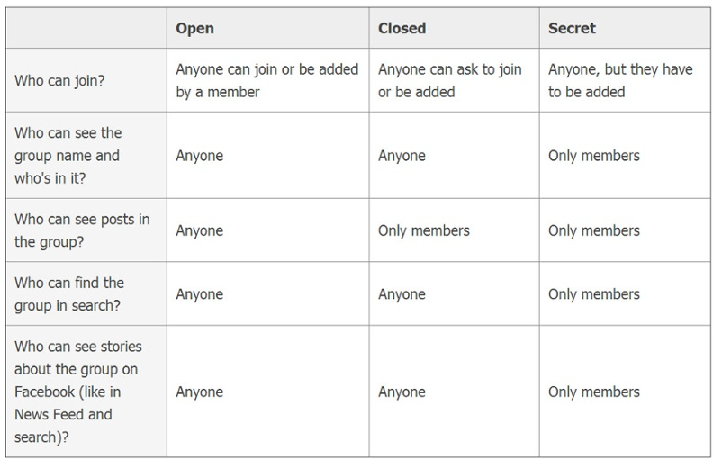

Select privacy: Select “Closed group” from the dropdown options

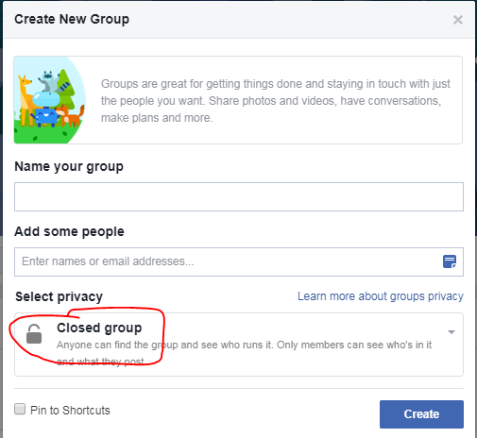

**Step 6: Click Create**

After you choose your privacy setting, click the "Create" button.

**Step 7: Add Your Cover Image**

Facebook will now give you the option to add your creative graphic for your header or cover image.

Upload photo provided by NEP

**Step 8: Complete "About" Section**

Your about section is important for 2 reasons:

* Gives prospective members an idea what your group is about
* Can display any "rules" you may have about the group

Description: Welcome to the XXXX County Facebook Live Healthy Choices for Every Body program. Members of this group will participate in live lessons, live food demonstrations and receive free kitchen tools upon completion of 7 required lessons and Entry & Exit Paperwork. This program is administered by the University of Kentucky Cooperative Extension Service, an equal opportunity university.

Group Type: Project

**Step 9: Edit Notifications**

As an admin you should turn the notifications on to receive all updates when anyone posts -- just in case someone spams the group & you want to respond quickly.

You do this by clicking on the “Notifications” tab and then clicking on “All Posts”:

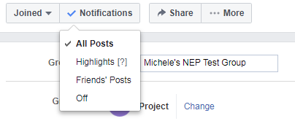

**Step 9: Edit Group Settings**

You do this by clicking on the "More" tab and then clicking "Edit Group Settings":

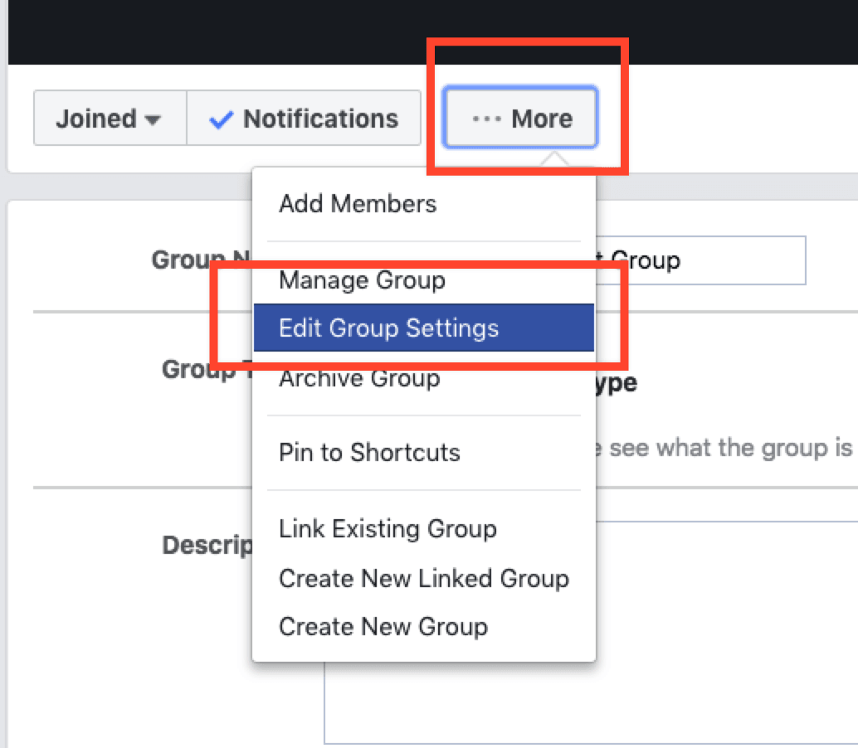

Once on the edit page, you will have many options to change, including:

* **Group Name:** *as previously noted*
* **Group Type:** *as previously noted*
* **Description:** *as previously noted*
* **Locations:** Add your city, state
* **Tags (up to 5 tags):** Food, Nutrition, SNAP
* **Linked Pages:** *don’t need to change anything*
* **Color:** *don’t need to change anything*
* **Web and Email Address:** *don’t need to change anything*
* **Privacy Settings:** *as previously noted (Closed group)*
* **Badges:** *don’t need to change anything*
* **Sections:** *don’t need to change anything*
* **Membership Approval:** Only admins and moderators
* **Chat creation permissions**: Members, moderators and admins can create chats
* **Membership Preapprovals:***don’t need to change anything*
* **Membership Requests:** *don’t need to change anything*
* **Membership Requests from Pages:** Don’t allow Pages to join
* **Posting Permissions:** Anyone in the group
* **Post Approval:**  All group posts must be approved by an admin or a moderator
* **Story Posting Permissions**: Only admins
* **Story Post Approval:** Photos and videos added to the group story must be approved by an admin or a moderator

Once you are done and happy with the settings, click "Save".

**Your Group is Ready to Go!** Now you can post updates inside the groups.

**A Few Group Features to Point Out**

**Messages/Chat-** One of the great things about groups is you can initiate a group chat/message with either all members of a group or select members.

This is especially useful when you have an announcement to make or need to quickly collaborate on an item/issue.

**Events**- A feature probably not used often enough in Groups is Events. Inside the group you can create events that only members can see & RSVP for.

Just click on the "Events" tab to the left and then "Create Event" & the lightbox below will load to create your event.

**Files**- Inside groups you can share files of any kind as well as create Documents which group members can add to & collaborate on.

Think of this as your own little workspace within Facebook -- or perhaps a replacement for apps like Basecamp or Dropbox.