
California 4-H Report for
Primary Members
Manual & Forms
(Ages 5 to 8)

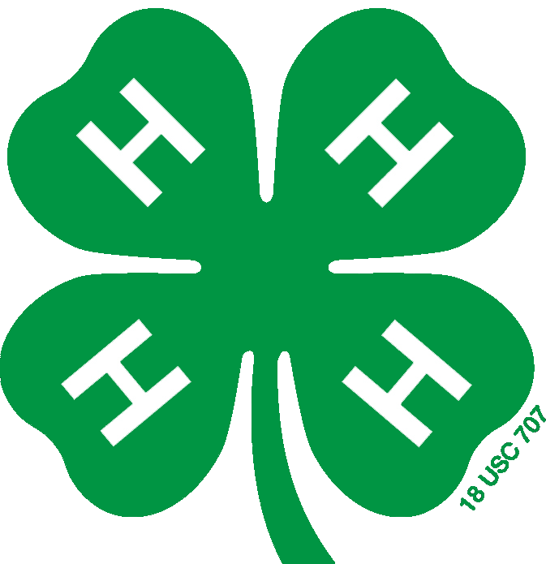

Table of Contents
Click on a section heading to jump to it.

Introduction 3
Definition of a 4-H Primary Member 3
Purpose of the 4-H Primary Member Program 3

Primary Member Report Form 4

Section 1: My 4-H Club and Events 5

Section 2: My 4-H Projects 6

Section 3: My Community 7

California State 4-H Office- 2801 Second Street Davis, CA 95618-7774 ca4h@ucanr.edu
Copyright © 2015 The Regents of the University of California.

It is the policy of the University of California (UC) and the UC Division of Agriculture & Natural Resources not to engage in discrimination against or harassment of any person in any of its programs or activities (Complete nondiscrimination policy statement can be found at http://ucanr.edu/sites/anrstaff/files/215244.pdf ) Inquiries regarding ANR’s nondiscrimination policies may be directed to John I. Sims, Affirmative Action Compliance Officer/Title IX Officer, University of California, Agriculture and Natural Resources, 2801 Second Street, Davis, CA 95618, (530) 750- 1397.
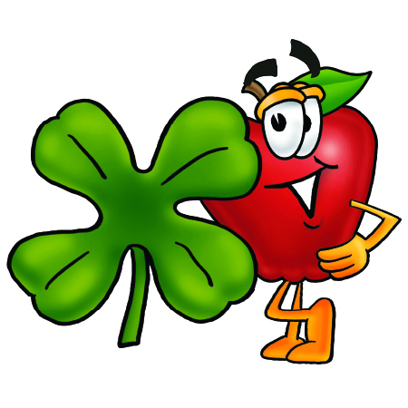

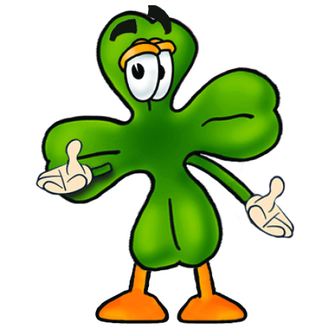


Introduction

Definition of a 4-H Primary Member
Primary members are youth between the ages of 5 and 8, enrolled in the 4-H program. Primary members must be 5 years old by December 31st of the program year and not older than 8 years old by December 31st of the program year. Youth who turn 9 on or after January 1st must participate as a primary member until June 30th of the program year.

Primary aged youth are impressionable and respond well to exciting and creative activities. This is a critical stage in the development of the young child and an excellent time to enhance a child’s learning experiences in self-perception.

Researchers estimate that children experience 50% of their learning before 4 years of age, another 30% before the age of 8. Therefore, it is important to offer non-formal, exploratory programs that focus on the developmental needs of younger children.

Purpose of the 4-H Primary Member Program
The purpose of the 4-H Primary Member Program is to assist youth in becoming capable, competent, caring and contributing citizens. Keep in mind that:
- Adult volunteers should provide open-ended activities that promote skills practice.
- Activities should focus on the process of doing things rather than the finished product.
- Activities should make use of participants' experience and encourage exploration, rather than written or verbal lessons.
- Participation for primary members should be limited to cooperative learning activities with no competition.

The California 4-H Youth Development Program (YDP) has specific policies for all of its programs, events and activities. Some policies are specifically related to primary aged members and activities while others govern all roles and responsibilities within the 4-H YDP. Before you begin the California 4-H iSprout project, be sure that you are familiar with and follow all of the California 4-H Youth Development Program policies, found at: http://4h.ucanr.edu/Administration/Policies/. The UCCE 4-H Office staff in your county can help you with specific questions that you may have about policy implementation.

Primary Member Report Form
This is a picture of me:

Name: ___________________________________ Program Year:_______________

4-H Club or Unit: _____________________________

County: ___________________________

Years in 4-H: ____________

Age: ____________

Address: _________________________________

City:___________________ State: ______

Zip: ________________

Phone: _(_____)_______-________

Club Meetings Attended This Year  Do not include project meetings. | Meetings Held | Meetings Attended | Hours Attended

- I made this report and I think it is correct.
Member’s Signature: | Date:
I have personally reviewed this report and believe it to be correct.
Parent/Guardian Signature: | Date:
4-H Adult Partner’s Signature: | Date:

Section 1: My 4-H Club and Events

Tell us about your 4-H Club! Write or draw.
The name of my 4-H Club is:

4-H meetings and events I attended. Write or draw.
The 4-H meetings and events I attended are:

Which event was your favorite? Write or draw.
My favorite event was:
This event was my favorite because:

Section 2: My 4-H Projects

Tell us about your projects! Write or draw.
The name of my 4-H project is:

My favorite thing about this project is:

Projects are about learning. What did you learn?
Some things I learned in this project are:
1.

2.

3.

4.

5.

Section 3: My Community

What do you care about?
Something that I care a lot about is:

That’s great that you care about something! Complete a community service activity for the topic you wrote above.
The community service activity that I completed was:

Congrats on making a difference! Fill in the boxes below (write or draw).
I did a community service activity with others!
Who we helped:
What we did:
When we did it
Where we did it:
Why we did this:

