FUNDRAISING GUIDELINES

- All methods of fundraising by 4-H units and councils must comply with UC’s general fund development guidelines given below. The regulations apply to those activities involving the solicitation and use of goods and services for 4-H YDP, as well as the solicitation of funds.
  - Any raising or use of funds by a 4-H unit or council must be for the purpose of furthering the research and education goals of the 4-H YDP.

- All fundraising activities in support of the 4-H YDP must comply with the following:
  - All proposed fundraising activities of 4-H units and VMOs must be submitted to the UCCE county office for approval by the county director or designee using Form 8.7 Fundraising Approval. The county director or designee is responsible for assuring fundraising activities are in compliance with applicable policies. Federal law regarding the use of the 4-H name applies in these activities. See Public Law 772.
  - Pertinent federal rules and regulations governing Using the 4-H Name and Emblem must also be followed. See also Fundraising: Private Support for the 4-H Program.
  - The 4-H Name and Emblem shall not be used to imply endorsement of commercial firms, products or services. See Fundraising: Sponsorships and Promotions.
  - In connection with 4-H fundraising purposes, the following disclaimer statement must be used on products or services offered for sale: “A portion of the sales price of this product or service will be used to promote 4-H educational programs. No endorsement of the product or service by 4-H is implied or intended.”
  - Public, non-profit agencies, such as the 4-H YDP are not to conduct lotteries, drawings, raffles, bingo, and other games of chance. See Raffles, Lotteries, Gaming and 4-H.

/tmp/in/input.doc

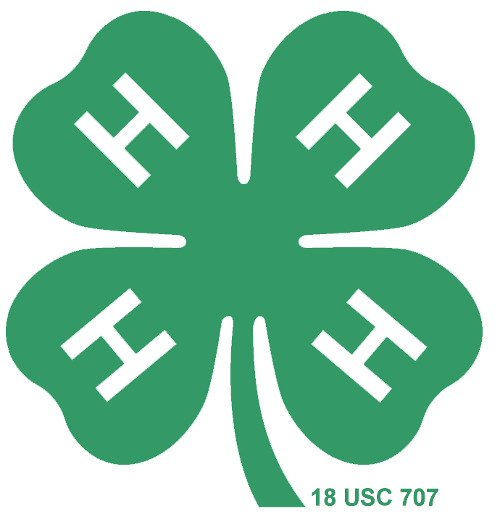

A portion of the sales price of this product or service will be used to promote 4-H educational programs. No endorsement of the product or service by 4-H is implied or intended.

