Roller Coasters
Adapted from Design It! Balls & Tracks

Background Information
An engineering challenge to design ski jumps and roller coasters using marbles and foam pipe insulation. Youth will create a series of tracks involving a ball rolling through a series of twists and turns. Youth will learn about forces of motion, momentum.

Suggested Groupings
- Individual or pairs (teams should be no larger than 3 youth).

Time Required
- 45 to 60 minutes

Materials Needed
- Foam pipe insulation
- Masking tape, 1 roll for each group
- Marbles
- Scissors
- Cups or containers

Getting Ready
- Cut the foam pipe insulation in half.

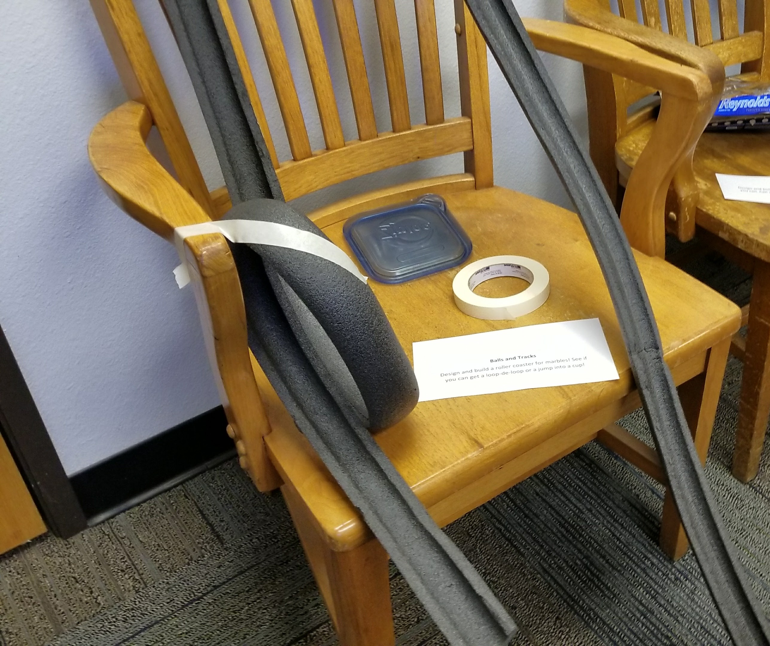
Opening Questions
Before starting the activity, ask youth these opening questions to get them thinking about the concepts that will be covered in the activity.
- What do you know about roller coasters?
- What do you think is important to consider when building a roller coaster?

Procedure (Experiencing)

- Share the materials available and then share the design challenge:
Set up a roller coaster that will thrill the theme park visitors! Add as many hills, loops, jumps, or spirals as you can. Marbles will be the guests, so make it a long and memorable roller coaster for them.

- Allow teams 20 to 30 minutes to construct, build, and test their roller coasters. For teams that finish early, give them more advanced challenges, such as: Add a jump between two pieces of track. Add a loop to your roller coaster. Add a spiral to your roller coaster.
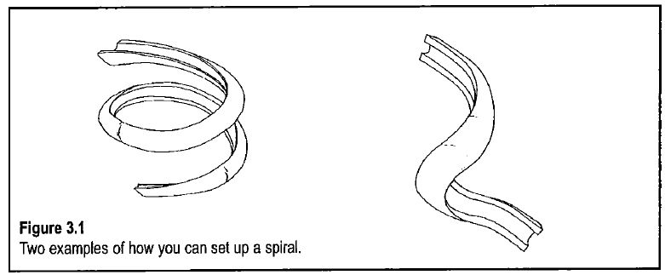 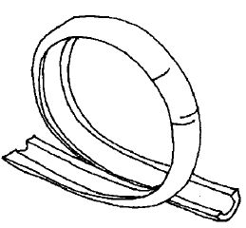
- When time is up, invite each team to demonstrate their roller coaster to the class.

Sharing, Processing, and Generalizing (Reflection)
At the conclusion of the day’s activities, ask youth to share their contribution one-by-one and reflect:
- What types of designs appeared to work the best?
- What design issues did you experience with your roller coaster? How did you solve it?
