PARTS OF THE ANIMAL

Test # ________

Score_________

Beef Level 1 & 2
Name_________________ Club_________________

Put the number next to the name. Identify as many as you can. You will not be penalized for incorrect answers. Level 1 scored up to 10 parts. Level 2 scored up to 20 parts.

Test being updated for 2016. This will be the picture used:

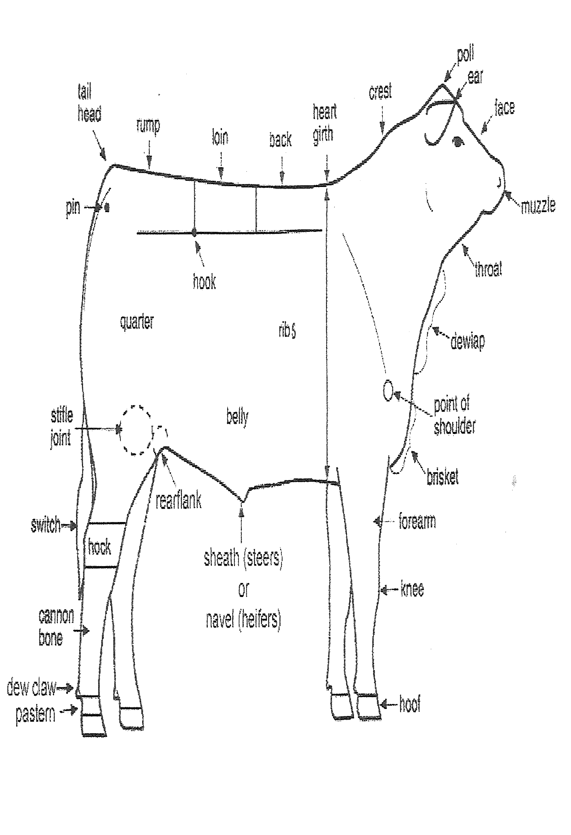

Beef Test Level 1-2 2016

