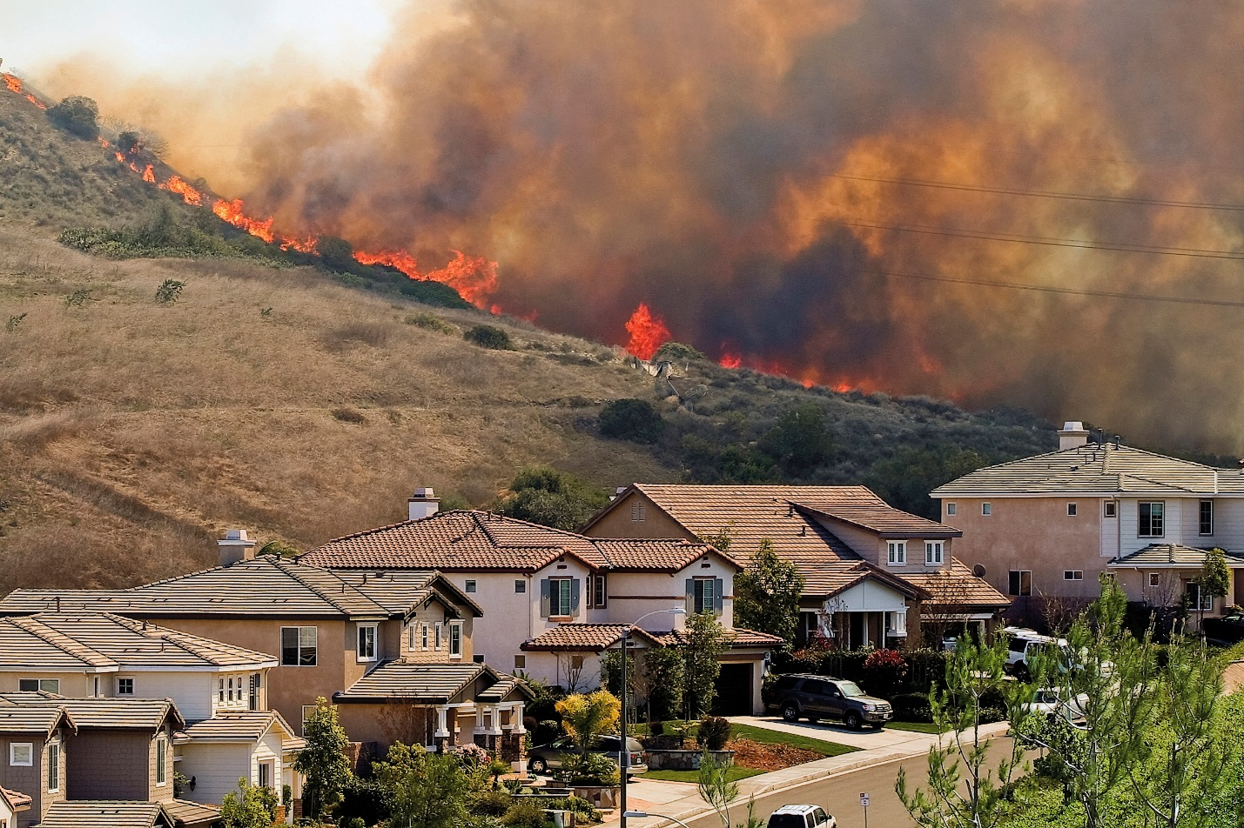

Despite recent rain in California, the state has experienced record dry conditions with the potential to result in an explosive wildfire season. California has declared May 4 -10, 2014 “Wildfire Awareness Week,” urging residents to prepare homes for potential wildfires.

"Creating and maintaining Defensible Space is critical for the protection of homes," said Chief Ken Pimlott, [CAL FIRE](http://www.readyforwildfire.org/) director. "It has never been more critical to strengthen our fire prevention efforts in light of the elevated fire conditions we have been experiencing in California. We have increased our inspection staffing and now we need the public to make sure they, too, are prepared for the increased fire risk due to drought."

**Create a Defensible Space of 100 Feet**

Homeowners can easily create a defensible space to help protect their home and improve the homes chance of surviving a wildfire through easy maintenance practices. A minimum defensible space of 100 feet around your home is required by California law (Public Resources Code 4291). Check with your local fire department for specific defensible space requirements in your area.  
  
Creating a 100 foot defensible space around the home is oftentimes the easiest and most effective first line of defense in protecting a home against wildfires. According to [Landscaping Tips to Help Defend your Home from Wildfire](http://firecenter.berkeley.edu/docs/CeMasterGardener8322.pdf), the goal of the law is to protect your home while providing a safe area for firefighters.

**Create a Lean, Clean and Green Zone**

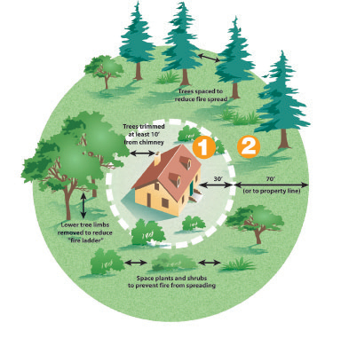A buffer between structures and trees, grass and shrubs and helps slow or stop the spread of wildfire. Break the property surrounding your home down into two zones:

**Zone 1:**Zone one extends 30 feet* out from buildings, structures, decks, etc.

* Remove all dead plants, grass and weeds (vegetation).
* Remove dead or dry leaves and pine needles from your yard, roof and rain gutters.
* Trim trees regularly to keep branches a minimum of 10 feet from other trees.
* Remove branches that hang over your roof and keep dead branches 10 feet away from your chimney.

Photo Credit: CAL FIRE, [www.fire.ca.gov](http://www.fire.ca.gov)

* Relocate wood piles into Zone 2.
* Remove or prune flammable plants and shrubs near windows.
* Remove vegetation and items that could catch fire from around and under decks.
* Create a separation between trees, shrubs and items that could catch fire, such as patio furniture, wood piles, swing sets, etc.

* San Diego County requires 50 feet of clearance in zone one. Check with your local fire department for any additional defensible space or weed abatement ordinances.

**Zone 2:**

* Cut or mow annual grass down to a maximum height of 4 inches.
* Create horizontal spacing between shrubs and trees. (See diagram)
* Create vertical spacing between grass, shrubs and trees. (See diagram)
* Remove fallen leaves, needles, twigs, bark, cones, and small branches. However, they may be permitted to a depth of 3 inches.

Prepared homeowners are not only protecting their property but also providing a safe environment for firefighters responding to the call of duty. Visit [California Garden Web](http://anrcatalog.ucdavis.edu/pdf/8228.pdf) or [ReadyforWildfire.org](http://www.ReadyforWildfire.org) for more information about preparing your home for wildfire season and fire-resistant landscaping.