PARTS OF THE ANIMAL

Meat Goat Level 1 & 2 & 3

Level I score 10 correct; Level 2 score 20 correct; Level 3 write in answers 70% Correct
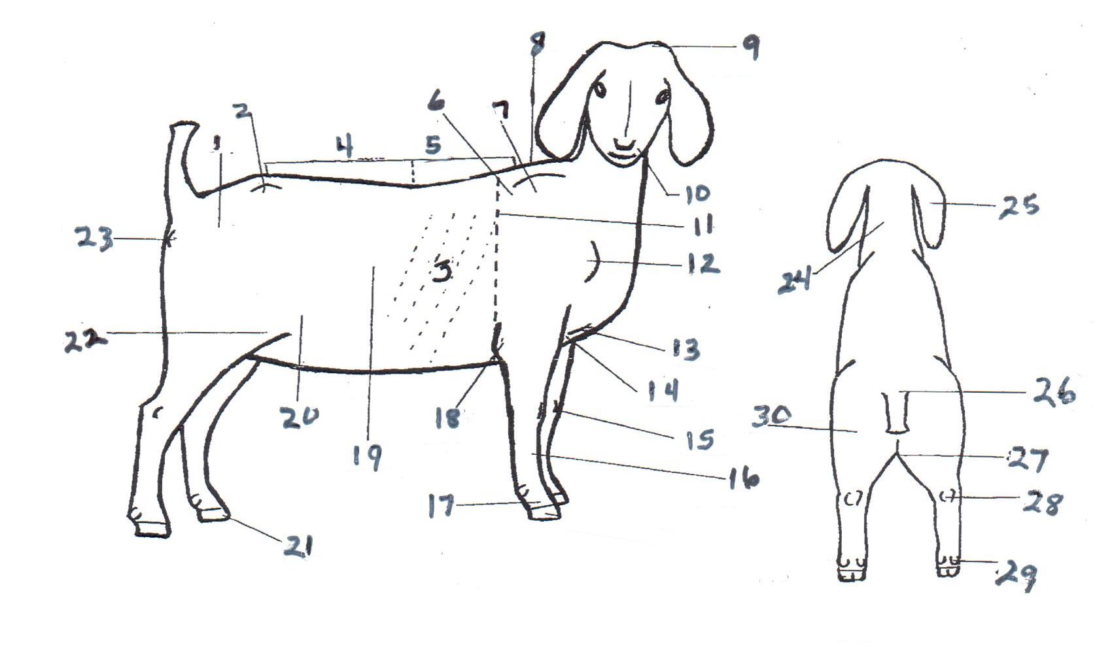

- Rump
- Hook or Hip
- Ribs
- Loin
- Chine
- Crop
- Shoulder blade
- Withers
- Poll
- Muzzle
- Heart girth
- Point of Shoulder
- Brisket
- Chest floor
- Knee
- Cannon bone
- Pastern
- Point of elbow
- Barrel
- Flank
- Hoof
- Stifle
- Pin bone
- Neck
- Ear
- Tail Head
- Twist
- Hock
- Dew Claw
- Thigh

Meat Goat Test Level 1-2 2015

