PARTS OF THE ANIMAL

Test # _______

Score _______

Sheep Level 1 & 2
Name_________________ Club_______________

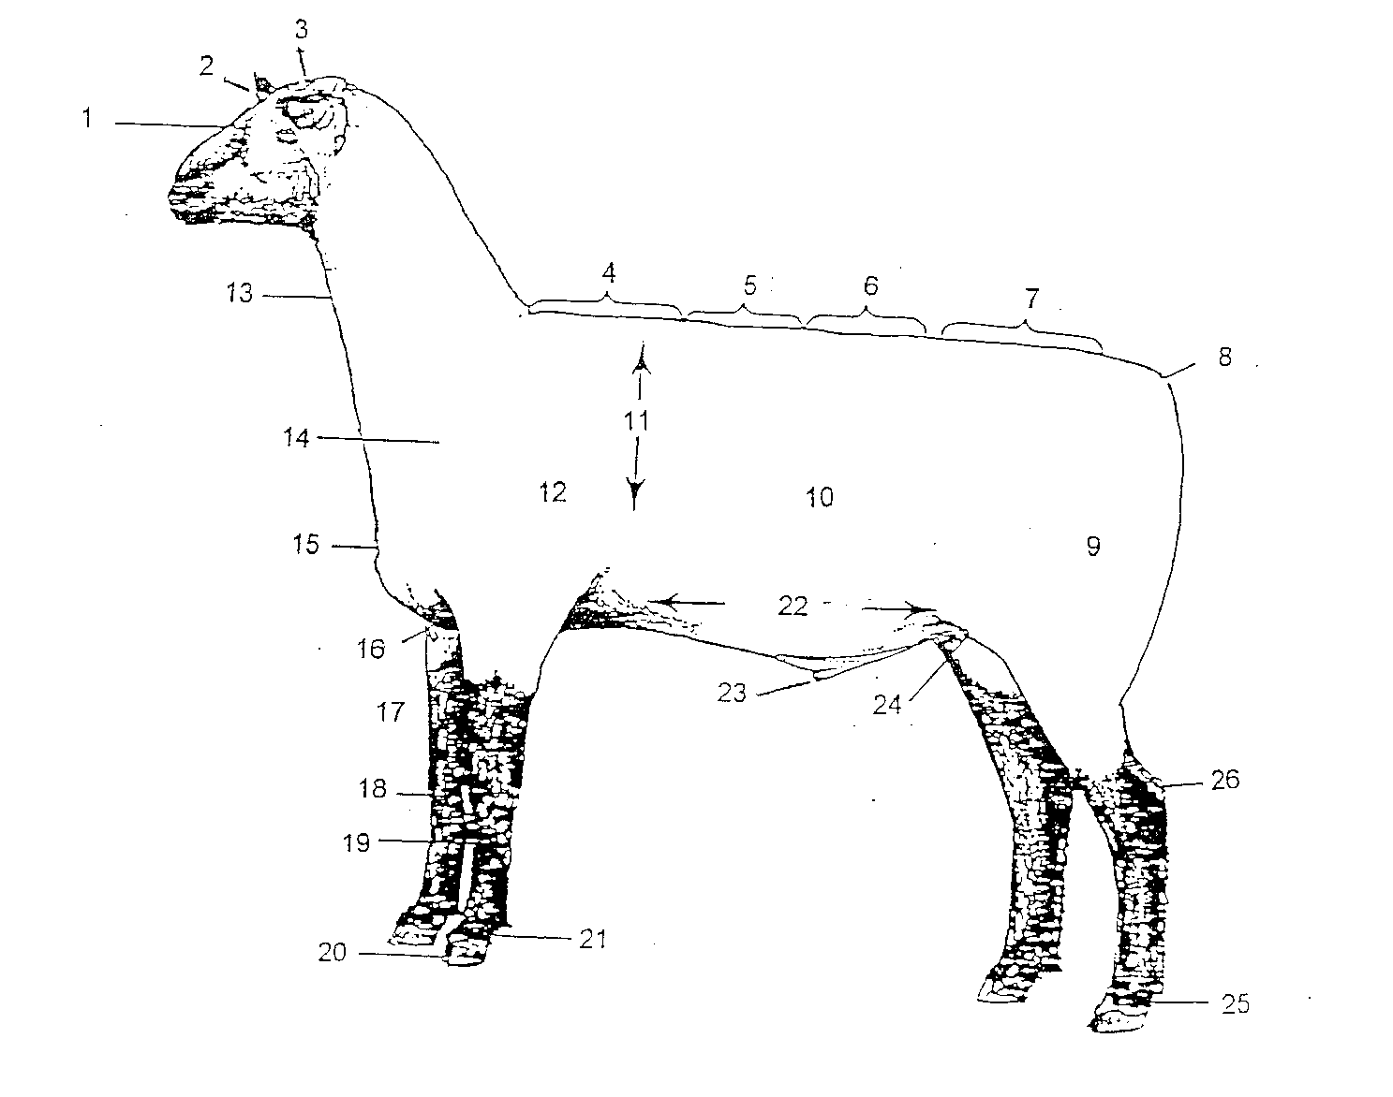
Identify as many as you can. Put the number next to the name. You will not be penalized for incorrect answers. Level I scored up to 10. Level II scored up to 20 parts.

_____Forerib
_____Back
_____Front pastern
_____ Rack
_____ Dock
_____ Middle
_____ Rump
_____ Face
_____ Shoulder
_____ Neck
_____ Point of shoulder
_____ Leg
_____ Chest
_____ Hoof
_____ Underline
_____ Hind pastern
_____ Forearm
_____ Cannon
_____ Sheath
_____ Poll
_____ Hock
_____ Ear
_____ Chest floor
_____ Loin
_____ Knee
_____ Flank

