WHOLESALE CUTS

Test # _________
Score__________
Beef Level 3 2009

Beef Level 3

Name_____________________ Club ______________________
Name a retail cut from each section. Answer as many as possible. Scored on 10. Wrong answers do not count against you.
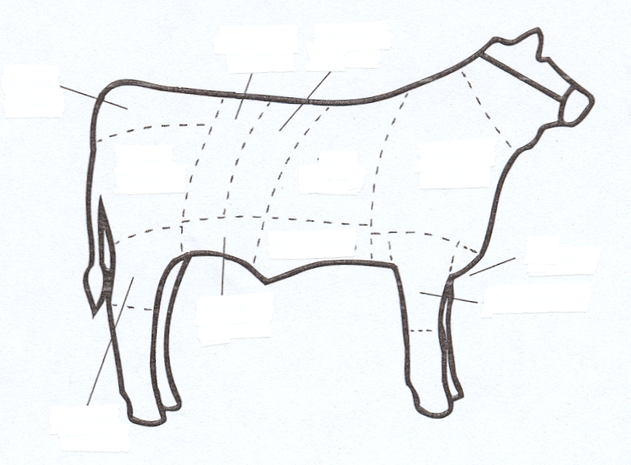

2
3
1
⁴
⁵
⁶
⁷
⁸
⁹
¹⁰
¹¹

- ______________________
- ______________________
- ______________________
- ______________________
- ______________________
- ______________________
- ______________________
- ______________________
- ______________________
- ______________________
- ______________________

Beef Test Level 3 ‘09

