BEEF
TEST # ___________
SCORE: __________
Meat Goat – Level II 2009
Level 2
CONFIRMATION TRAITS
Circle the correct answer on these 5 multiple choice questions.

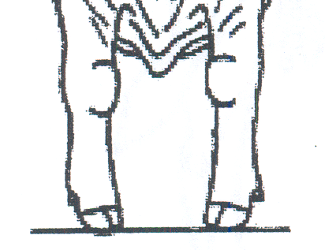
1. The drawing to the left best shows which front leg alignment:
- Knocked-Kneed
- Bow Legged
- Pigeon-toed
- The correct Front Leg Alignment

2. The drawing to the left best shows which front leg alignment:
A. Knocked-Kneed
B. Bow Legged
C. Pigeon-toed
D. The correct Front Leg Alignment

3. The drawing to the left best shows which front legSet:
A. Over the knee
B. Back at the Knee (Calf kneed)
C. Weak Pasterns
D. The correct Front Leg Set

4. The drawing to the left best shows which rear leg alignment:
A. Cow Hocked
B. Bow Legged
C. Pigeon-toed
D. The correct Rear Leg Alignment

5. The drawing to the left best shows which rear leg set:
A. Extremely curved (sickled)
B. Extremely straight (posty)
C. Low tail set
D. The correct Rear Leg Set

