Dairy Cattle
TEST # ___________
SCORE: __________
Dairy Cattle – Level II 2011
Level 2
CONFIRMATION TRAITS
Circle the correct answer on these 5 multiple choice questions.

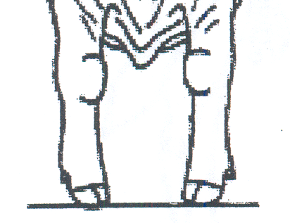
1. The drawing to the left best shows which front leg alignment:
- Knocked-Kneed
- Bow Legged
- Pigeon-toed
- The correct Front Leg Alignment

2. The drawing to the left best shows which front leg alignment:
A. Knocked-Kneed
B. Bow Legged
C. Pigeon-toed
D. The correct Front Leg Alignment

3. The drawing to the left best shows which front leg set:
A. Over the knee
B. Back at the Knee (Calf kneed)
C. Weak Pasterns
D. The correct Front Leg Set

4. The drawing to the left best shows which rear leg alignment:
A. Cow Hocked
B. Bow Legged
C. Pigeon-toed
D. The correct Rear Leg Alignment

5. The drawing to the left best which of the following fore Udder
Attachments:
- Bulgy attachment.
- Broken attachment
- High attachment
- The correct Fore Udder Attachment

