WHOLESALE CUTS
Meat Goat Level 3 2009
TEST # _____________
SCORE: ____________

Meat Goats Level 3
Name a retail cut from each section –no two from the same section

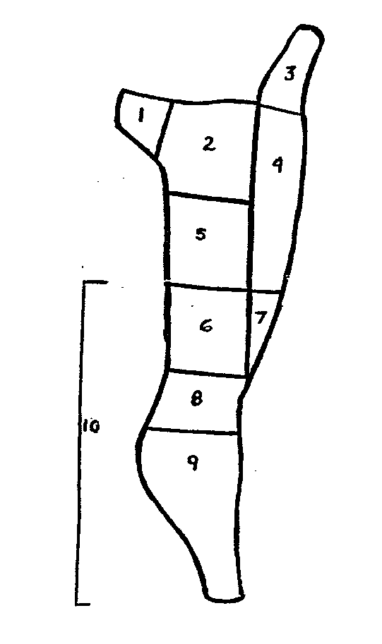
1._______________________________

2. _______________________________

3._______________________________

4._______________________________

5._______________________________

6._______________________________

7._______________________________

8._______________________________

9._______________________________

10._______________________________

Breast, Neck, Rack, Leg, Loin, Shoulder, Shank, Flank, Sirloin, Hindsaddle

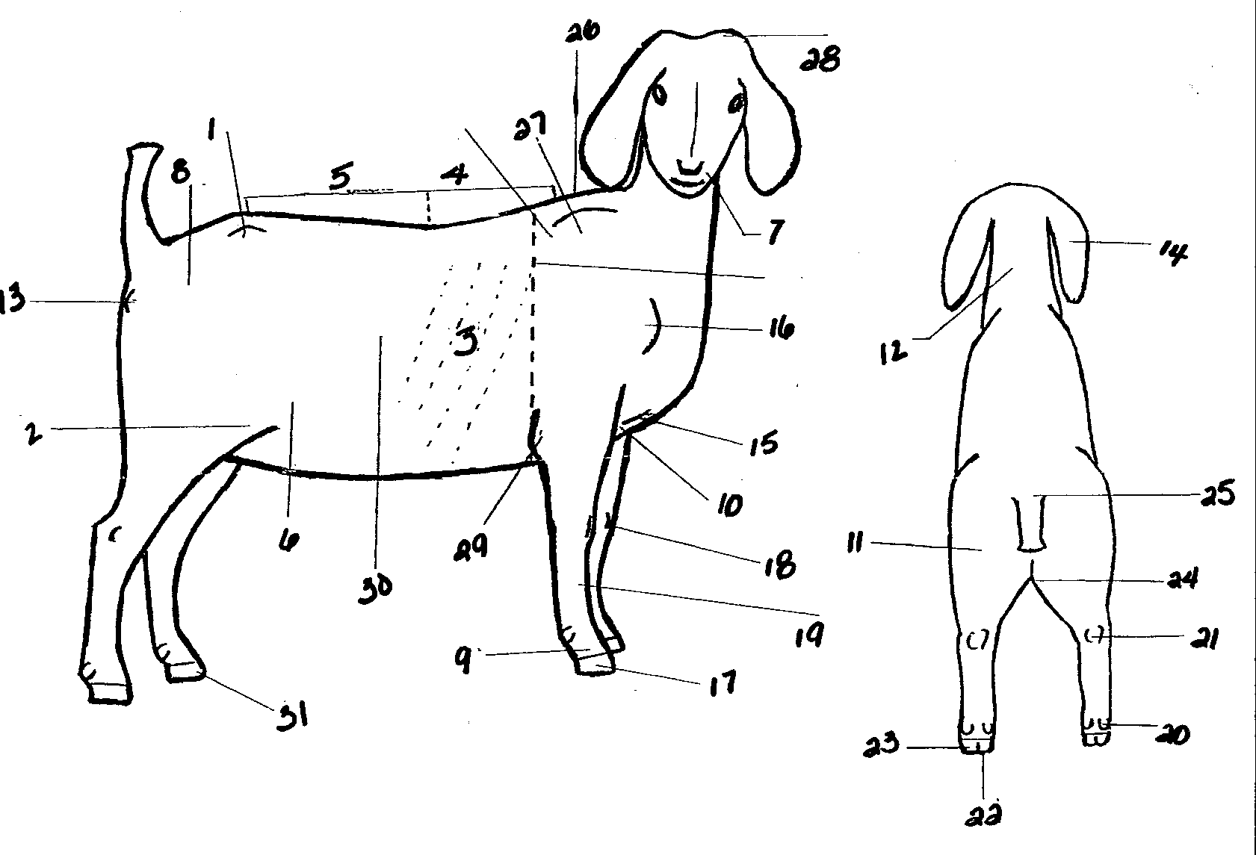
Meat Goat Parts Identification - Level 3
TEST # _________________
SCORE: ________________
Identify as many as you can. Put the number next to the name. You are not penalized for incorrect answers. Level 3 scored on 25 correct.

1. ______________________
2. ______________________
3. ______________________
4. ______________________
5. ______________________
6. ______________________
7. ______________________
8. ______________________
9. ______________________
10. ______________________
11. ______________________
Meat Goat Level 3 2009

12. ______________________
13. ______________________
14. ______________________
15. ______________________
16. ______________________
17. ______________________
18. ______________________
19. ______________________
20. ______________________
21. ______________________
22. ______________________
23. ______________________
24. ______________________
25. ______________________
26. ______________________
27. ______________________
28. ______________________
29. ______________________
30. ______________________
31. ______________________

QUIZ

Score__________

Meat Goat Level 3

Meat Goat level 3 ‘06

