Summary of Nitrification Inhibitor Trials
University of California Cooperative Extension, Monterey County
Richard Smith, Tim Hartz and Aaron Heinrich, Vegetable Crop and Weed Science Farm Advisor, Extension Vegetable Specialist and Staff Research Assistant

Due to the issuance of the Agicultural Order by the Central Coast Regional Water Quality Control Board on November 19, 2010, there is greater urgency to finding ways to complying with the proposed restrictions on the quantities of nitrogen that can be applied to leafy vegetables. The nitrate quick test is the most effective tool for measuring residual nitrogen in the soil and reducing fertilizer applications accordingly. In 2010 trials we reduced nitrogen applications to 6 lettuce fields by 31% over the standard fertilizer program. The vegetable industry is also looking at other technologies to reduce nitrogen fertilizer rates of lettuce such as slow release fertilizers, foliar nitrogen applications and other technologies. In this article we discuss research on a promising technology that may affect nitrate leaching losses.

Nitrification inhibitors slow the conversion of ammonium to nitrate by temporarily disrupting the activity of the bacteria Nitrosomonas and Nitrobacter (Figure 1). These species are responsible for converting ammonium to nitrate, a process called nitrification. The benefits of inhibiting nitrification is that ammonium has a positive charge and is attracted to the cation exchange sites in the soil and is therefore less prone to leaching than the negatively charged nitrate molecule. Nitrification inhibitors are commonly used in the corn belt and have been shown, under certain conditions, to improve yield and reduce nitrate losses to leaching and denitrification. N-Stinct (formerly called N-Serv) is the most commonly used nitrification inhibitor in the corn belt and has been extensively studied for many years; however, it is not registered for use on lettuce.

Dicyandiamide (DCD) is the only nitrification inhibitor available for use on lettuce. The commercial fertilizer additive ‘Agrotain plus’ contains DCD as well as a urease inhibitor to reduce ammonia volatilization; since ammonia volatilization is mostly an issue when fertilizer is surface broadcast (not a common practice in lettuce production), our interest in evaluating Agrotain plus was for the action of DCD. Data from a trial conducted at UC Davis on corn illustrates the potential benefits that nitrification inhibitors can provide to crop production (Figure 2). In this trial the yield of the 100 and 200 lbs N/A treatments were improved with the addition of Agrotain plus. In response to this positive data we conducted a laboratory soil column study and three field trials with lettuce.

At UC Davis columns of soil were fertilized either with a coated urea fertilizer, or with coated urea together with Agrotain plus. These columns were incubated for six weeks at room temperature; at two week intervals they were thoroughly leached, and the amount of nitrate in the leachate was determined. The Agrotain plus did suppress nitrate leaching through the first two leaching cycles (Fig. 3), with the effect wearing off thereafter. One reason for the short duration of activity is that DCD is reasonably soluble, and can itself be leached with excessive irrigation.

In all the lettuce field trials an untreated and standard treatments were compared with a low and moderate level of nitrogen with and without DCD. Agrotain was mixed with UN32 at the rate of 15 lbs Agrotain per ton of UN32 (wt/wt) and injected in the drip irrigation system at thinning and 7-10 days following thinning (Figure 4). In all trials mineral nitrogen was monitored each week following thinning, biomass N and tissue nitrate were monitored 2-3 times per season and yield evaluations were conducted.

In 2008 we conducted an on-farm trial and one at the Hartnell East Campus Research Station. In these trials, no statistically significant improvements in yield or the nitrogen status of the soil were observed. In the on-farm trial, residual soil nitrogen levels were high and no yield response was observed in any treatments (Table 1). In the Hartnell trial, yield response between all fertilizer treatments and the untreated control was observed, but no differences between fertilizer treatments were observed (data not shown).

In 2010, we applied irrigation water at 120% of crop ET. Soil nitrate levels were low (app. 10 ppm nitrate-N) at the time of the first fertigation on June 15 (28 days after germination water DAGW) (Figure 5). The first soil nitrate evaluation following this fertigation on June 25 (37 DAGW) showed a clear separation between the 160, 110 and 60 lbs N/A rates. However, there were no differences between the 60 and 110 treatments with or without Agrotain on this date. On the July 9 (52 DAGW), there was significantly higher nitrate-N in the 60+Agrotain treatment than in the 60 lbs N/A alone.

Lysimeter data clearly shows an N rate response (Figure 6). There are no statistical differences between N rates with or without Agrotain, but trends were observed that may be cause for optimism and clearly point the need for further research. Biomass, biomass N, leaf N and yield data show a clear N rate response (Table 2). No statistical differences were observed between N rates with or without Agrotain.

Conclusion: Nitrification inhibitors have potential to reduce nitrate leaching and increase nitrogen use efficiency. However, measurable agronomic or environmental improvement will not be seen in all field conditions. We believe that additional work is justified to develop ways to effectively utilize nitrification inhibitors in lettuce production.

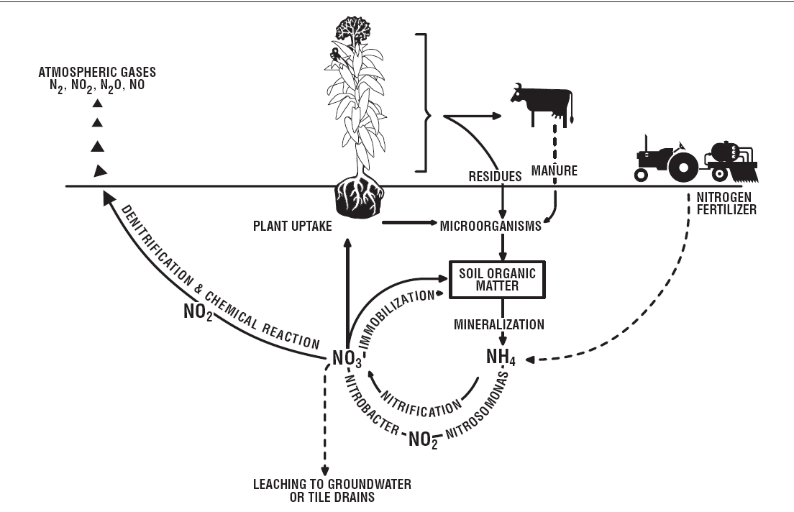
Figure 1. Nitrogen cycle: note the role of Nitrosomonas and Nitrobacter bacteria in converting ammonium to nitrate

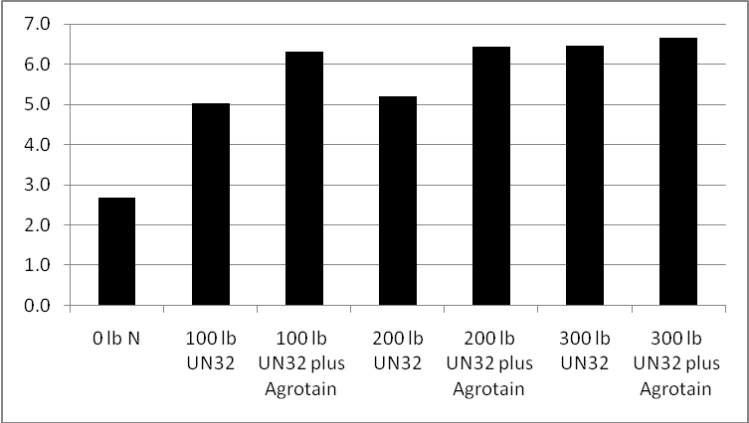
Figure 2. Corn yield in various fertilizer and fertilizer + Agrotain treatments
(From J. Mitchell)

Fig. 3. Effect of Agrotain plus on nitrate leaching loss in UCD column study.

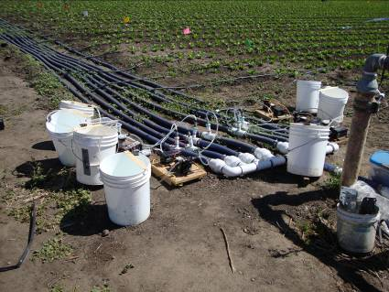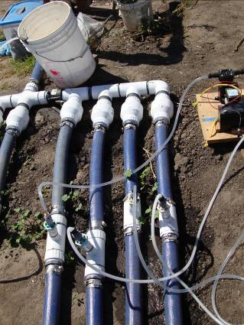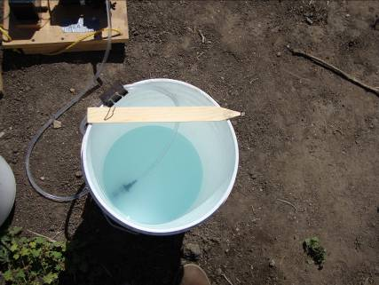
Figure 4. Fertilizer/nitrification inhibitor injection manifolds and fertilizer + Agrotain mixture

Table 1. 2008. On-farm trial. Harvest evaluation on May 24.
Treatment  total lbs N/A  applied | Untrimmed yield lbs/A | nitrogen  in tops  percent | Nitrogen in tops lbs/A | Trimmed head weight  lbs/A | Mean head weight Untrimmed  lbs/head | Mean head  weight  Trimmed  lbs/head | Percent marketable  after trimming
198.1 (Standard) | 89,022.5 | 3.9 | 115.7 | 51,929.2 | 2.9 | 1.7 | 58.5
146.6+ Agrotain | 82,495.7 | 3.4 | 113.9 | 54,344.5 | 2.8 | 1.8 | 65.6
146.6 | 81,075.5 | 3.7 | 118.5 | 49,199.5 | 2.7 | 1.7 | 60.6
119.1+ Agrotain | 82,420.1 | 3.4 | 104.6 | 50,070.0 | 2.7 | 1.6 | 60.7
119.1 | 89,207.2 | 3.6 | 134.1 | 47,205.1 | 2.8 | 1.5 | 53.2
Untreated | 83,229.3 | 3.4 | 112.0 | 46,262.1 | 2.7 | 1.5 | 55.2
Pr>F treat | 0.0634 | 0.0027 | 0.7350 | 0.8129 | 0.1561 | 0.6673 | 0.5166
LSD 0.05 | NS | 0.2 | NS | NS | NS | NS | NS

Table 2. 2010. Biomass and biomass N on two dates, % N in leaf tissue on one date and harvest evaluation on July 21
Treatments | T/A  Biomass | Lbs N/A  Biomass | % N in leaf | T/A  Biomass | Lbs N/A  Biomass | T/A  Untrimmed | Lbs N/A  Biomass | T/A  Trimmed
Treatments | June 24 |  | July 2 | July 8 |  | July 21
Untreated | 1.8 | 8.6 | 3.03 | 8.5 | 26.1 | 15.1 | 35.5 | 12.4
160 lbs N/A | 2.2 | 14.6 | 4.62 | 15.5 | 72.4 | 35.1 | 112.0 | 28.7
60 lbs N/A | 1.9 | 12.0 | 4.05 | 11.9 | 45.1 | 24.4 | 68.6 | 20.5
110 lbs N/A | 2.2 | 14.3 | 4.47 | 14.3 | 61.3 | 32.1 | 95.8 | 27.5
60 lbs N/A + Agrotain | 2.0 | 11.2 | 3.92 | 12.2 | 45.9 | 26.0 | 72.0 | 22.7
110 lbs N/A + Agrotain | 2.3 | 15.0 | 4.40 | 15.0 | 62.7 | 33.0 | 99.6 | 28.1
Pr>F treat | 0.242 | 0.008 | <0.001 | <0.001 | <0.001 | <0.001 | <0.001 | <0.001
Pr>F block | 0.079 | 0.041 | 0.011 | 0.281 | 0.239 | <0.001 | 0.012 | <0.001
LSD 0.05 | NS | 3.2 | 0.24 | 2.4 | 9.3 | 3.8 | 13.7 | 3.4

Figure 5. 2010. Soil nitrate-N over the growing season (DAGW = days after germination water). Error bars represent SE (n=3)

Figure 6. 2010. Nitrate-N concentration in leachate of various treatments

